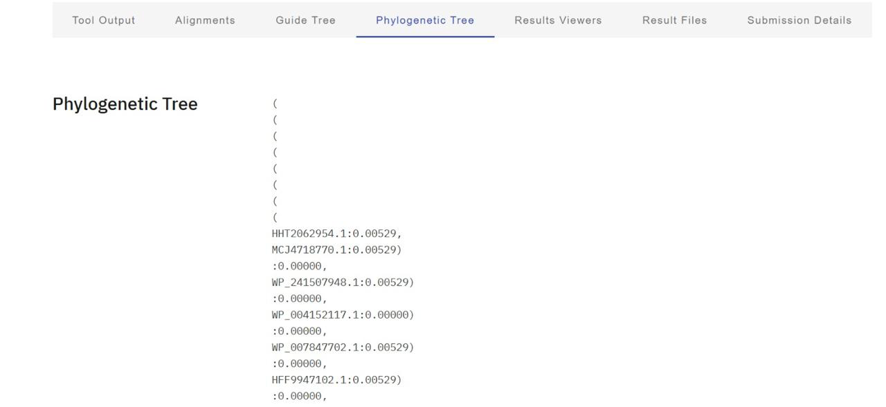
5.⁠ ⁠Phylogenetic Analysis

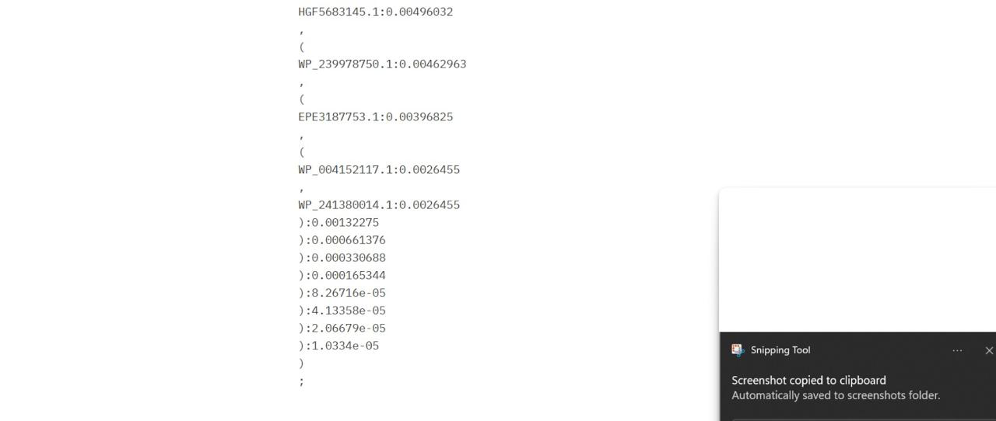

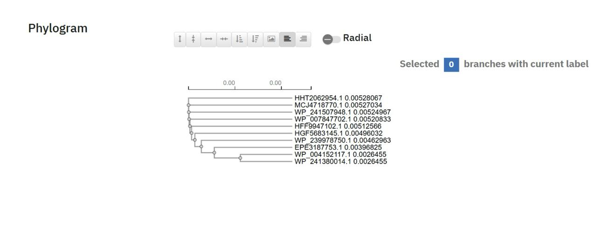

Interpretation of the phylogram (evolutionary relationship)

This phylogram represents the evolutionary relationships among closely related homologous protein sequences (accession IDs such as WP_, EP_, HHT_, HGF_). The tree is drawn as a phylogram, meaning that branch lengths are proportional to evolutionary distance (sequence divergence).
Key observations from the tree
1. High overall sequence similarity
• All branch lengths are very short (≈ 0.0026–0.0053 substitutions/site).
• This indicates that all sequences are highly conserved and likely belong to the same protein family with similar structure and function.
2. Two closely related sub-clusters
• Cluster I (upper group):
• HHT2062954.1
• MCJ4718770.1
• WP_241507948.1
• WP_007847702.1
• HFF9947102.1
• These sequences share almost identical branch lengths, suggesting recent divergence from a common ancestor.
• Cluster II (lower group):
• HGF5683145.1
• WP_239978750.1
• EPZ3187753.1
• WP_004152117.1
• WP_241380014.1
• This group forms a slightly more diverged clade, but still remains very close evolutionarily.
3. Closest evolutionary pairs
• WP_004152117.1 and WP_241380014.1
• They share the shortest branch lengths (~0.00265), indicating they are the most closely related sequences in the dataset—possibly orthologs from closely related species or strains.
• Similar tight pairing is seen among the upper cluster sequences.
4. Single common ancestor
• The short internal nodes and lack of deep branching show that all sequences originated from a single recent ancestral gene.
• There is no evidence of ancient duplication or functional divergence.
Evolutionary implications
• The protein is evolutionarily conserved, suggesting:
• An essential biological role
• Strong purifying (negative) selection
• Minor divergence likely reflects:
• Species or strain-level variation
• Adaptation without loss of core function

Functional inference

Because:
• Sequence divergence is minimal
• No long or isolated branches are present

The proteins likely:
• Perform the same or very similar function
• Have conserved subcellular localization and biochemical activity

